# Question 01

## Code

### Function

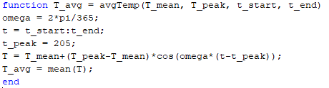

### Test case

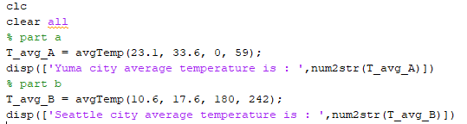

## Output



# Question 02

## Code

clc

clear all

% rearrange equation in matrix form

A=[0 -7 5;0 4 7;-4 3 -7];

B=[50;-30;40];

C=inv(A)*B;

x1=C(1)

x2=C(2)

x3=C(3)

## Output

